**Project Activity 2**

Chimzim Ogbondah and Samuel Moore

Team_01

1. Use case for extension
   1. 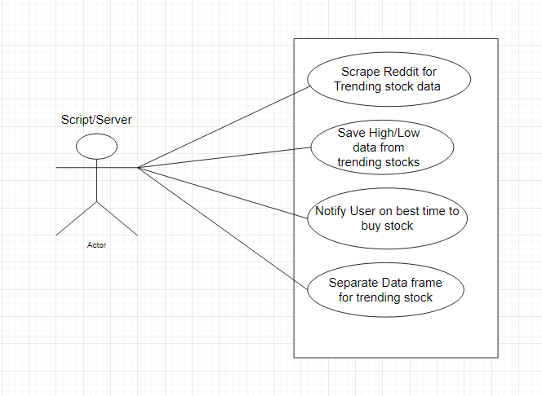
   2. **Trending Stock data:** *The system should also be able to scrape reddit and detect stocks that are trending which is different from what the user is looking for.*
   3. **High and low data:** *The system should be able to save the High and Low data based on the trending stocks it has detected from reddit*
   4. **Notify User on purchase time:** *The system should notify the user on the optimal time to purchase a stock. This can be a stock found through trending information on reddit or through the users words/tickers. Should analyze historical stock data to get time.*
   5. **Separate data frames:** *The system should create separate data frames for the user. One should come from the users input using the words and tickers. The other should be from the trending stocks found on reddit. These should be separate so the user can differentiate between their own data and what is currently trending on reddit.*
2. **Quality Attributes** : Response time for Saving High and Low data, Response time for notifying the user on optimal stock purchase time, Response time for identifying trending stocks via Reddit
   1. Scenario : **Performance for periodical trending stock data**
   2. Stimulus - Every hour
   3. Stimulus source - Server/Script application
   4. Response - Scrape subreddit and check for trending stock information
   5. Response measure - < 10 minutes
   6. Environment - normal and overload
   7. Artifact - word / tickers, respective subreddits
   8. Scenario : **Performance for saving high and low data**
   9. Stimulus - regular application
   10. Stimulus source - server/script
   11. Response - query for the high and low data from yahoo finance
   12. Response measure - < 5 seconds
   13. Environment - normal and overload
   14. Artifact - ticker, yahoo finance api
   15. Scenario : **Performance for notifying user on optimal stock purchase time**
   16. Stimulus - words/tickers & yahoo finance API
   17. Stimulus source - Server/script application
   18. Response - analyzing historical trends for stock data
   19. Response measure - < 15 seconds
   20. Environment - normal and overload
   21. Artifact - yahoo finance API & ticker & common trend data
3. **Constraints**
   1. Must be compatible with yahoo finance API (to retrieve data)
   2. Must be compatible with reddit API (to scrape)
   3. Must be compatible with mobile and home/work computers
   4. Must be able to support a minimum of 100 concurrent users
   5. Must be able to function on poor internet connection
4. **Concerns**
   1. Leverage team’s knowledge of of python
   2. Knowledge of data analysis
   3. Appointing someone to facilitate the separation of work
   4. Developing a quick and efficient plan for architecture of the application